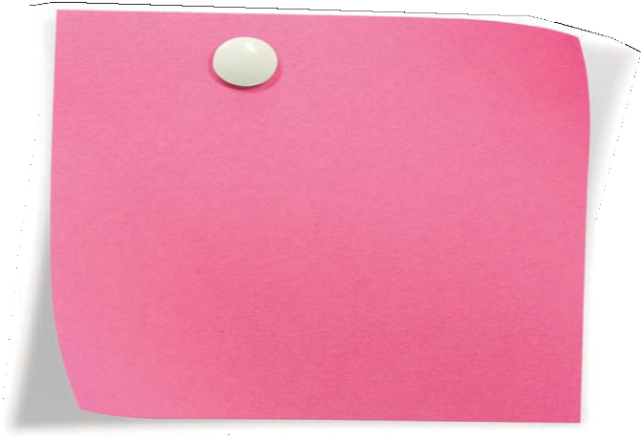
SAMPLE
BOARD
MEMBER
LETTER OF
AGREEMENT

TOOL 24

As a board member of the XYZ, I am fully committed to the mission and have pledged to help carry it out. I understand that my duties and responsibilities include the following:
- I will be fiscally responsible, with other board members, for this organization. I will know what our budget is and
take an active part in reviewing, approving, and monitoring the budget.
- I know my legal responsibilities for this organization as a member of the board and will take an active part in establishing and overseeing the organization’s policies and programs.
- I will act in accordance with the bylaws and operating principles outlined in the manual and understand that I am morally responsible, as a member of the board, for the health and well- being of this organization.
- I will give what is for me a substantial annual financial donation.
- I will actively participate in fundraising in whatever ways are best suited for me and agreed on with those in charge of the organization’s fundraising. These may include individual solicitations, undertaking special events, writing mail appeals, and the like. I am making a good faith agreement to do my best and to help raise as much money as I can.
- I will actively promote XYZ in the community and will encourage and support its staff.
- I will prepare for and attend board meetings, be available for phone consultation, and serve on at least one committee, as needed.
- If I am not able to meet my obligations as a board member, I will offer my resignation.
- In signing this document, I understand that no quotas are being set and that no rigid standards of measurement and achievement are being formed, and trust that all board members will carry out the above agreements to the best of our ability.

Signed:
Date:
Received by:
Date:

Excerpted from The Board Building Cycle: Nine Steps to Finding, Recruiting, and Engaging Nonprofit Board Members, Second Edition, by Berit M. Lakey. BoardSource, 2007.

© 2009 BoardSource RECRUITING A STRONGER BOARD 49

